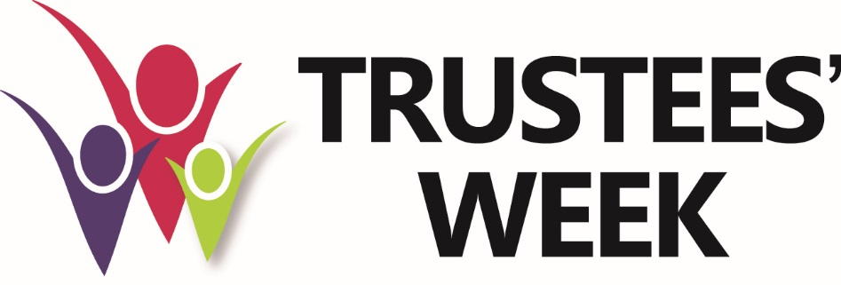
News release for immediate use 22 September 2016
Charity coalition focus on leadership development for Trustees’ Week 2016
A coalition of charities, regulators and professional bodies has announced details of this year’s Trustees’ Week, 7—13 November 2016. A series of events, resources and information will be made available to the public on the theme of good leadership and effective chairing of charity trustee boards.

“Stronger charities through good leadership”
Trustees’ Week 2016 celebrates the UK’s 1 million trustees and promotes the benefits of volunteering to be a trustee. Independent research shows that the UK is number 6 in the world for giving and volunteering and trustees play a vital role in making our charity sector so vibrant and strong. This year Trustees’ Week will focus on good governance and the skills needed to make trustees effective leaders.

The coalition is inviting charities and charity trustees to get involved in Trustees’ Week by joining in with webinars, live events and social media. We’re also inviting charities and other bodies to list trustee-matching, training and celebration events on our website.

Trustees’ Week 2016 highlights
- NCVO/ BWB and Third Sector Governance Forum’s charity conferences on Monday 7th November
- Charity Commission Webinar on good governance for Trustees on Tuesday 8th November, 7-8pm – free online
- Free training resources from umbrella bodies and professional bodies
- Trustees tweeting about their experiences on @trusteesweek

Our focus on skills this year to help trustees identify gaps
"Small charities are the lifeblood of their communities. They face multiple challenges that can make it difficult to develop good governance. This is all the more reason to build and have good strategies in place. People become trustees because they are passionate about the cause, and we need to recognise, support and celebrate those who are upskilling themselves to ensure vital work in their communities continues and their charities thrive." - Rebecca Bunce, Head of Policy and Engagement, Small Charities Coalition.

‘Good governance is underpinned by good trustees. Board members who are engaged in their roles and keen to develop their skills and knowledge are central to the effectiveness of voluntary sector organisations. They play a vital role in helping charities make a bigger difference. I am very much looking forward to Trustees’ Week as an opportunity to celebrate the great work of trustees.’ - Sir Stuart Etherington, chief executive of the National Council for Voluntary Organisations, which represents charities and volunteering.

“The last year has shown the challenges of trusteeship. It can be hard, but it’s worth it. Charities and trustees achieve so much that is valuable and worth celebrating. You should step forward to become a trustee. The Commission, charities and professional bodies supporting Trustees’ Week are ready to help you equip yourself to be the best trustee you can be!”- Paula Sussex, Chief Executive of the Charity Commission, regulator for charities in England and Wales.

Celebrating the hard work of trustees
"Smaller charities rely on support from trustees. People who voluntarily give their time to help make a difference. So it’s a huge pleasure to support Trustees’ Week and celebrate their work.” – Neil Cleeveley, Chief Executive, NAVCA, the national membership charity for local voluntary sector infrastructure in England.

Contacts
England & Wales - Press office at the Charity Commission: – office hours 0300 065 2123; pressenquiries@charitycommission.gsi.gov.uk
Scotland – Press office at OSCR: - office hours 01382 220446; Judith.Pogorzelec@oscr.org.uk
Northern Ireland – press office at CCNI: - office hours 02838 320220; Shirley.kernan@charitycommissionni.org.uk

Notes to editors:
- Trustees’ Week 2016, http://trusteesweek.org/ will mark seven years since the beginning of this annual celebration of trusteeship, which aims to highlight the work that trustees do and their function in the good governance of charities. It draws attention to the opportunities for people from all walks of life to get involved and make a difference by volunteering to become a charity trustee.
- It is run by a coalition of charities, umbrella organisations, professional bodies and regulators.
- You can read case studies about Trustees here: http://trusteesweek.org/stories/
- Add your event to Trustees’ Week here: http://trusteesweek.org/contact-us/
- Find trustee vacancies through these links: http://trusteesweek.org/becoming-a-trustee/
- Charities improve life in the UK in many different ways, with over 94% of people in the UK making use of a charity each year, whether it’s having a day out at a National Trust property, using a hospice, youth group or other service.
- Of our nearly 1m trustees, over 120,000 are new in position each year.
- There are trustees of all ages and the split is approximately half and half between men and women. The average trustee in England and Wales is 59, but in Northern Ireland is 55.

https://www.cafonline.org/about-us/publications/2015-publications/world-giving-index-2015
Public Trust & Confidence Research, 2016 https://www.gov.uk/government/publications/public-trust-and-confidence-in-charities-2016

